Lay Terminology

📘 What is Lay Terminology
# Source: AI Source: Provided by: [Data Path: Persons Table -> ID Column: 1, Name_En Column: Motasem Essam] -> From: [Chatgpt (GPT-4-turbo)] on [7/31/2025]
Lay Terminology refers to non-technical, everyday language used by the general public to describe specialized or technical concepts in simpler terms.

✅ Key Features:
# Source: AI Source: Provided by: [Data Path: Persons Table -> ID Column: 1, Name_En Column: Motasem Essam] -> From: [Chatgpt (GPT-4-turbo)] on [7/31/2025]
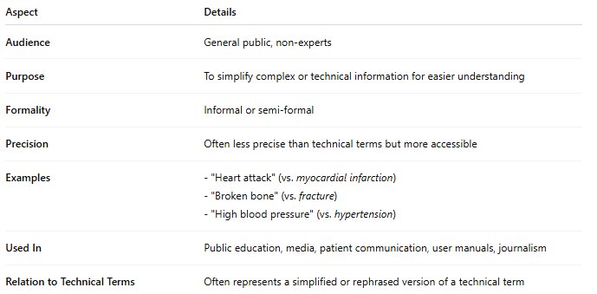
Aspect | Details
Audience | General public, non-experts
Purpose | To simplify complex or technical information for easier understanding
Formality | Informal or semi-formal
Precision | Often less precise than technical terms but more accessible
Examples | - "Heart attack" (vs. myocardial infarction) - "Broken bone" (vs. fracture) - "High blood pressure" (vs. hypertension)
Used In | Public education, media, patient communication, user manuals, journalism
Relation to Technical Terms | Often represents a simplified or rephrased version of a technical term

🧠 Summary:
# Source: AI Source: Provided by: [Data Path: Persons Table -> ID Column: 1, Name_En Column: Motasem Essam] -> From: [Chatgpt (GPT-4-turbo)] on [7/31/2025]
Lay terminology bridges the gap between specialists and non-experts, helping ensure clear communication with audiences unfamiliar with the technical jargon.

